MAGR Practical 2

Martijn Koenis 3770214

Xhi Jian Tan 3774759

Milo Buwalda 5571839

What have we done:

Basic shading.

Reflections.

Shadows.

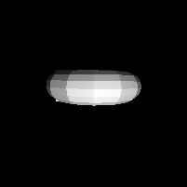

Local shading: top of taurus seen from above. Light source above it.

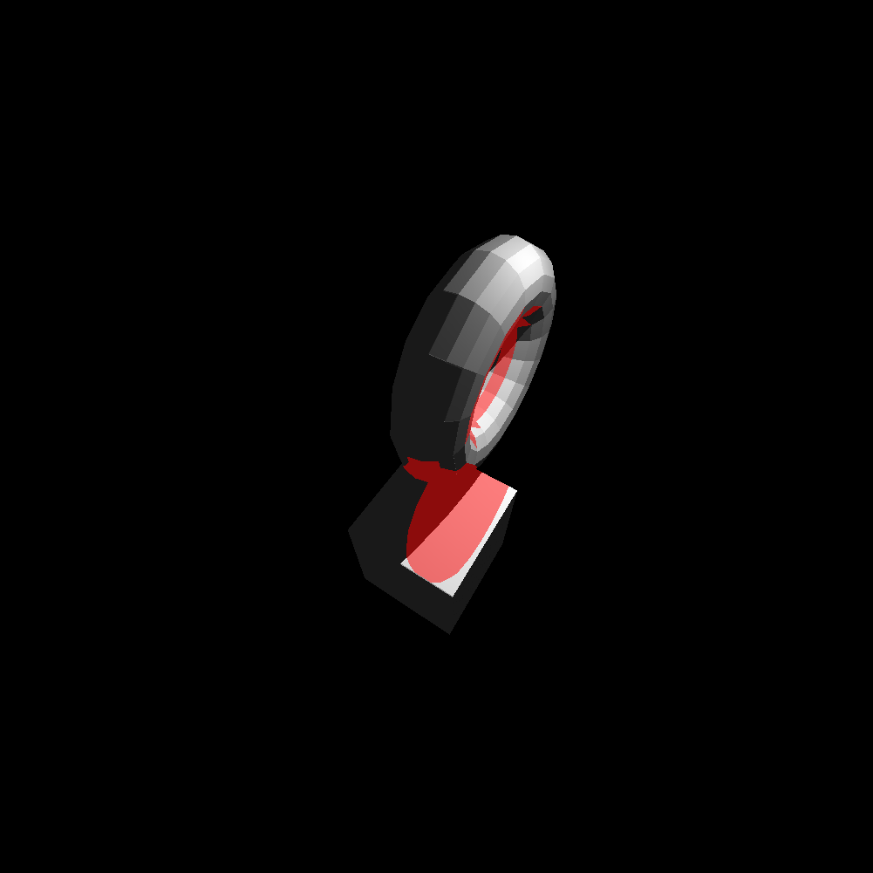

Local shading + shading + reflections. Reflections are made red for visibility purposes. Dark grey and red areas are shaded areas (they can not see the light source unobstructed). Light source is again above the objects.

Anti-Aliasing

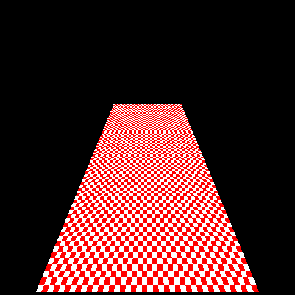

On the top of the rectangle you can see some aliasing problems.

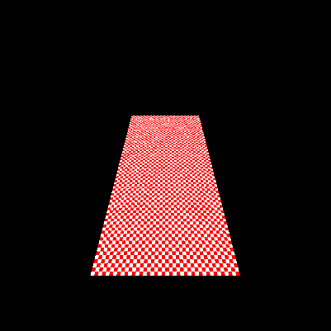

Here you can see the result when using 3 random rays inside each pixel. It slightly improves the picture but you can still see aliasing.

Gausions:

We found that increasing the sigma increases the smoothing/blurring. Tests with different sigmas (100\*100):

(for some reason enlarging in word also adds blurring so for clear images see pictures testWithGausians0.5, testWithGausians1, etc.)

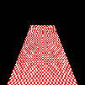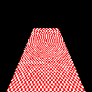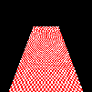

0.5 1 2

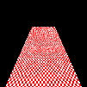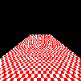

4 100\*100 without AA

The tradeoff seems to be that the larger the sigma the more aliasing disappears but also more blurring occurs.

Here is a 400\*400 picture with sigma = 4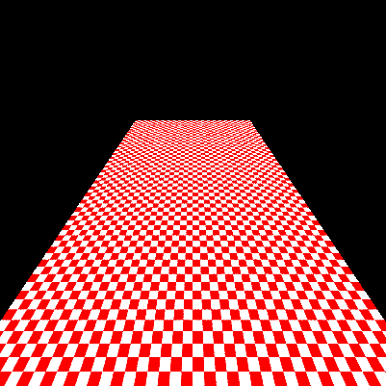

Little aliasing can be seen.